2024 Global Children’s Literature Teacher Fellowship Program Lesson Plan Template
Context
Lesson Title: The Truth About Dragons by Julie Leung
What was the context for your lesson?
1. Second Grade (Elementary K-5)
2. English Language Arts, Art
3. My second grade classroom has twenty-two students. Students reside in a suburban community that is shared with Michigan State University. Students are diverse among several different facets but most apparent being race, ethnicity, religion, language, and socioeconomic status.
4. As someone with a multicultural heritage—my Oma being German and my father a first-generation American—I bring personal understanding and empathy to this lesson. Growing up, I experienced the richness of diverse family narratives firsthand, which informs my approach to teaching. Having worked with students from multicultural families, I recognize the importance of validating their identities and fostering a sense of belonging. Through this lesson, I aimed to celebrate cultural diversity, promote empathy, and empower students to embrace their unique family stories and traditions.
Process
How did you select the literature for your lesson?
1. Literature:
Leung, J., & Cha, H. (2023). The Truth About Dragons. Henry Holt Books for Young Readers.
I also used a variety of texts for students to reference when comparing and contrasting Western and Eastern dragons. I also tagged specific pages that students could use as a resource when we were discussing symbolism of dragons in both cultures. Reference texts are all listed here.
2. What was your process for literature selection?
I began my search for literature using the Michigan State University Libraries website. I specifically looked for Asian and Pacific American Awards for Literature. I wanted a book that my students potentially had not seen yet, so I was in search of something that had been recently published. Once I selected a few texts I researched both the author and the illustrated. I wanted the author and illustrator to have a personal connection to the culture of the text that I choose. I also considered what my students were interested in when selecting a text.
3. Where and how did you learn about this literature (browsing, internet search, award lists, in-person recommendation, etc.)
I found this specific book on two award lists: Asian/Pacific American Awards for Literature and Caldecott Medal Winner which is how I selected it.
4. Did you consult some of the resources identified in the library visit and the Zoom meetings?
- Asian/Pacific American Awards for Literature
- Caldecott Medal Winner
Lesson
1. What do you want students to learn? (goals)
- Students will be able to compare and contrast physical and symbolic characteristics Eastern and Western dragons using The Truth About Dragons as a mentor text, along with other supporting texts.
- Students will be able to create their own dragon and write about its characteristics both physical and symbolic.

2. Why does this lesson matter from the perspective of global understanding and engagement?
- Enrichment of Personal and Family Identity: Incorporating stories from diverse cultures into family life enriches personal and familial identities. It allows individuals to celebrate their own cultural heritage while embracing the richness of others. This sense of pride in one's cultural background, coupled with an appreciation for others', fosters a strong sense of belonging and unity within the family unit.
- Promotion of Cultural Awareness and Respect: By exploring stories from diverse cultures, individuals develop a deeper understanding of the beliefs, traditions, and values that shape societies worldwide. This exposure fosters respect for cultural differences and promotes a sense of unity amidst diversity.
- Facilitation of Cross-Cultural Communication: Understanding the stories and symbols that hold significance in different cultures facilitates effective cross-cultural communication. It enables individuals to navigate cultural differences with sensitivity and openness, fostering meaningful interactions and collaboration on a global scale.

3. Lesson Plan:
Theme/Topic: Exploring Cultural Narratives and Symbols Through Eastern and Western Dragons with the book The Truth about Dragons by Julie Leung
Global Perspective: This lesson aims to foster an appreciation for cultural diversity by examining the symbolism and mythology associated with Eastern and Western dragons. By comparing and contrasting these cultural representations, students will gain insight into different perspectives and cultural narratives from around the world.
Activities/Instructional Approaches:
- Introduction/Background:
  - Begin the lesson by engaging students in a brief discussion about dragons. Ask open-ended questions to elicit prior knowledge and spark interest in the topic. Add ideas to a anchor chart.
  - Introduce the global perspective by explaining that dragons are prevalent in mythology and folklore around the world, with distinct representations in Eastern and Western cultures.
  - Provide students with background information on Eastern and Western dragons. Highlight key differences in appearance, symbolism, and cultural significance.
  - Show images or artifacts depicting Eastern and Western dragons to visually illustrate the differences.
Read Aloud:
- Provide students with a sticky note to write their new learning to add to an anchor chart while listening to the story.
- Read the story aloud to students. Consider these places to pause:
  - Page beginning with, “Dragons are fearsome…” What do you notice about the dragon on this page? What words does the author use to describe the dragon?
  - Page beginning with, “Dragons are majestic creatures” What do you notice about the dragon on this page? What words does the author use to describe the dragon?
  - Page beginning with, “Most adventures have…” Here are the two dragons together, what do you notice?
- Discussion of the value of hear different stories:
  - Page beginning with, “But my darling…” What does the author mean when she wrote, “inside your heart is where the two forests meet. Both journeys are yours to take. Both worlds are yours to discover”?
  - Page beginning with, “And two wise…” What story do you think the child will share? What story would you share?
- Drawing Activity:
  - Distribute drawing materials to students and instruct them to create a drawing using what they’ve learned about Eastern dragons and one of a Western dragons.
  - Encourage students to incorporate details that reflect the cultural symbolism and characteristics associated with the type of dragon.
  - Allow time for students to share and discuss their drawings with classmates, noting similarities and differences between the two representations.
- Comparative Analysis:
  - Facilitate a class discussion comparing and contrasting Eastern and Western dragons. Encourage students to consider differences in appearance, symbolism, mythology, and cultural context.
  - Provide guiding questions to prompt critical thinking and deeper analysis, such as: "How do Eastern and Western dragons differ in appearance?" "What cultural values or beliefs are associated with each type of dragon?"
- Reflection and Application:
  - Have students reflect on what they've learned about cultural diversity through the lens of dragons. Ask them to consider how cultural narratives and symbols shape our understanding of the world.
  - Challenge students to apply their understanding by writing a short paragraph that explains the significance of dragons in their own culture or a culture of their choice.
Artifacts: Artifacts for this lesson may include students' drawings of Eastern and Western dragons, as well as written reflections of their understanding of cultural symbolism.
Assessment: Student understanding will be assessed through participation in class discussions, the quality of their drawings, and the depth of reflection demonstrated in written assignments. Additionally, formative assessment will be ongoing throughout the lesson, allowing for real-time feedback and adjustment of instruction as needed.
Closure: Conclude the lesson by emphasizing the importance of cultural diversity and the value of understanding different perspectives. Encourage students to continue exploring global narratives and symbols in their future studies.

4. How will you know if students learned what you intended?
Assessment of student learning can be achieved by observing active participation and thoughtful contributions during discussions about the value of diverse family experiences and stories. Additionally, evaluating the accuracy and detail in their drawings of Eastern and Western dragons provides insight into comprehension. Subsequent discussions, where students compare and contrast these dragon depictions, reveal their understanding of similarities and differences. Through these methods, comprehension of cultural narrative significance, recognition of artistic symbolism, and ability to analyze cultural differences become evident, ensuring students have met the intended learning outcomes.
Enactment
The lesson, conducted on April 4th during ELA differentiated instruction, was well-received by students. They expressed enjoyment for the content and actively engaged in discussions, drawing connections to their personal cultural backgrounds. Artifacts such as drawings of Eastern and Western dragons showcased their creativity and understanding. Discussions about the value of diverse stories elicited thoughtful responses, demonstrating students' appreciation for cultural narratives. Providing various texts enriched their learning experience, allowing for deeper exploration. Overall, students' positive response, active participation, and meaningful connections to their own identities indicated the success of the lesson in fostering appreciation for cultural diversity and storytelling.
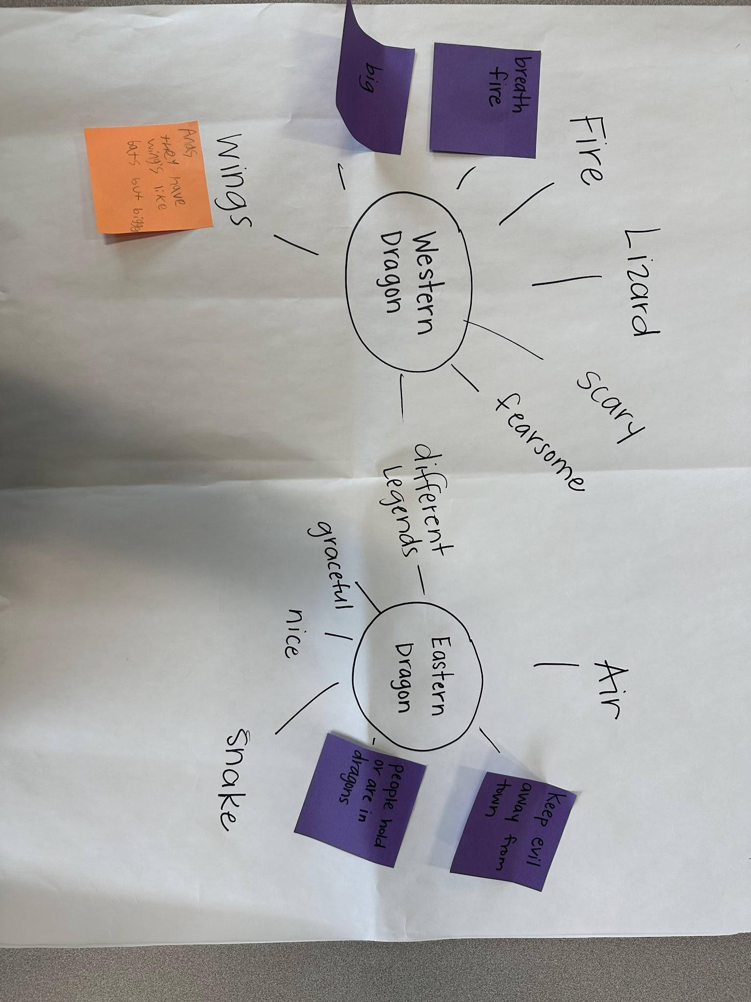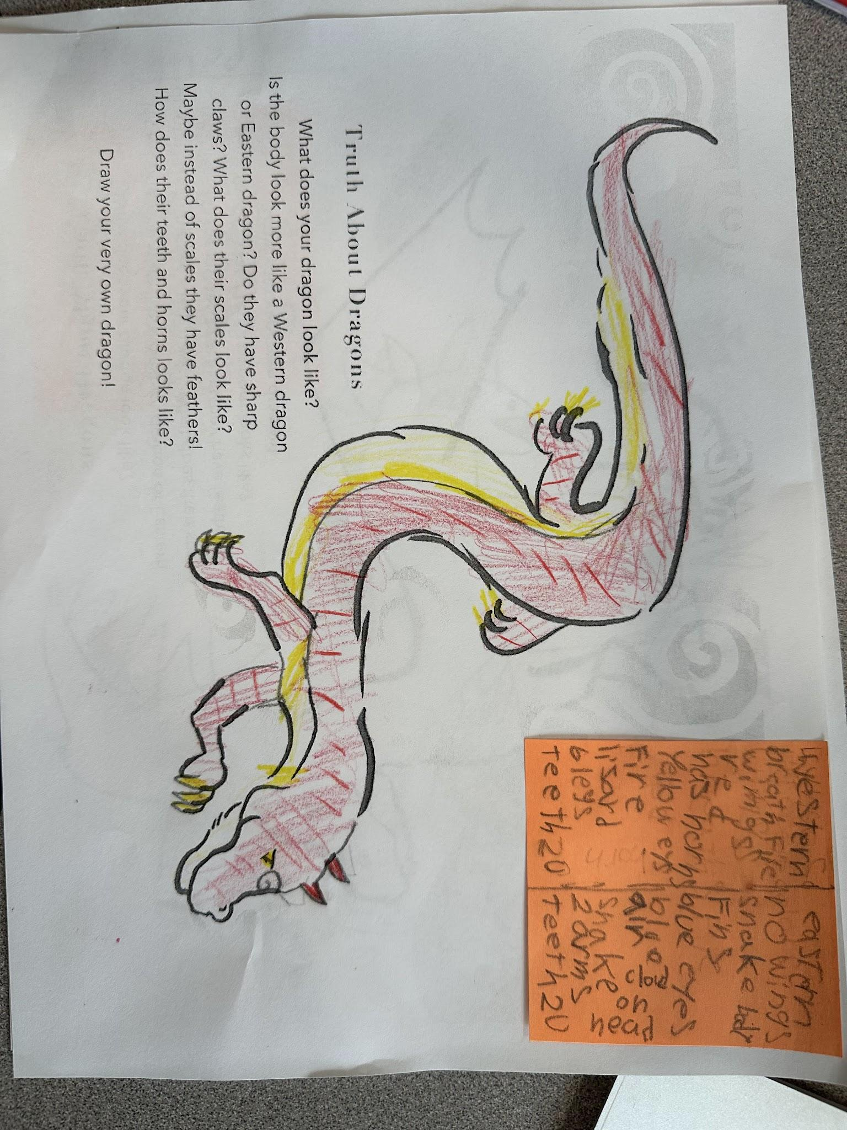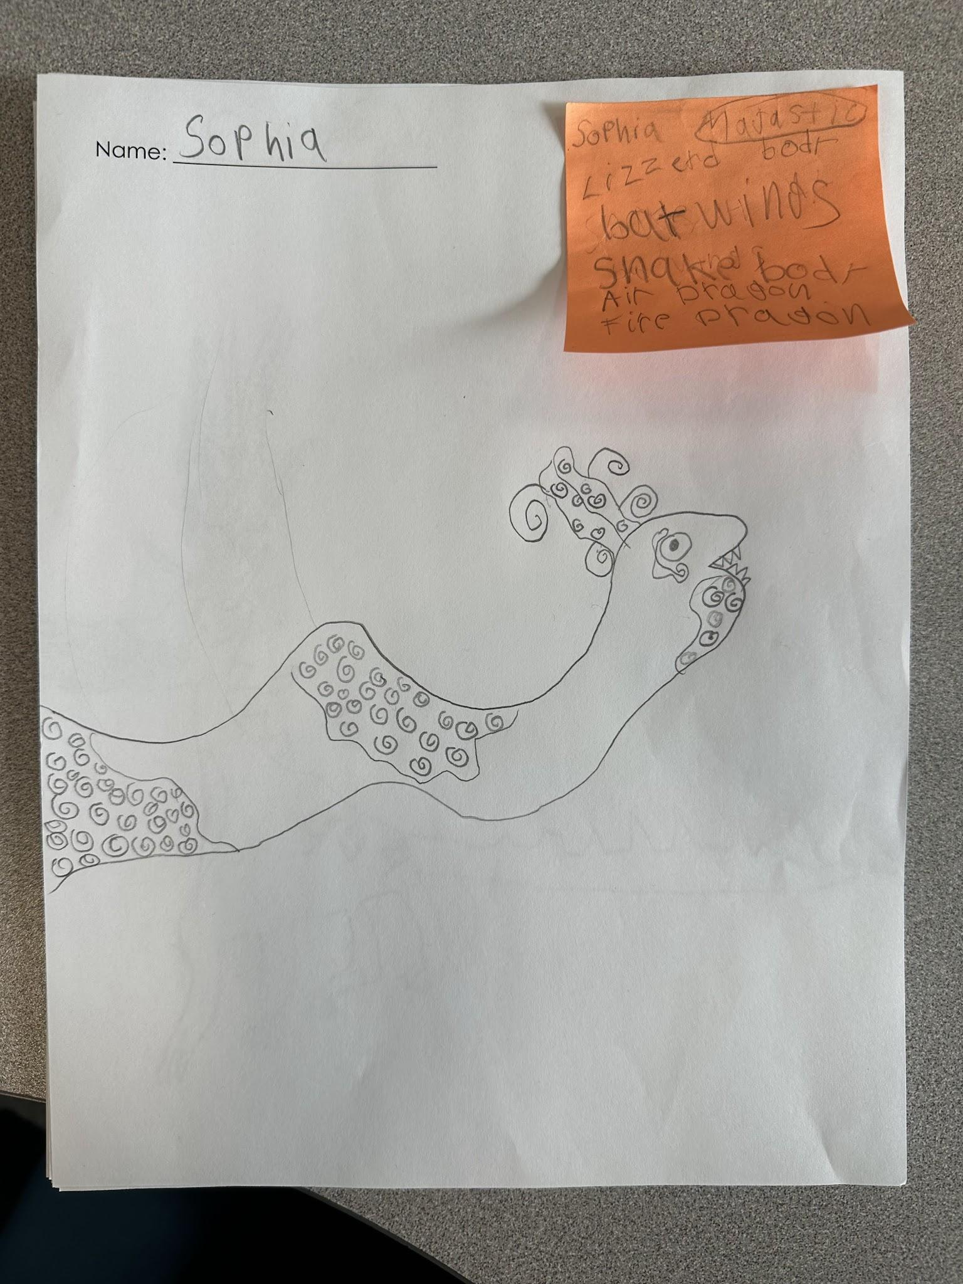
Reflection
Reflection (Self-evaluation)
1. What were you pleased with?
- I was pleased with the overall positive response from students, as they enjoyed the content and actively engaged with the lesson. Their ability to make connections to their personal cultural identities and participate in discussions about the value of different stories demonstrated their understanding and involvement. Providing various texts and referencing them enriched their learning experience by offering diverse perspectives.

2. Are there things you learned for next time?
- I learned the importance of time management and flexibility. Due to time constraints, I was only able to teach the lesson to a small group of students, limiting its impact. In the future, I would allocate more time or split the lesson across multiple days to ensure all students have the opportunity to participate fully. Additionally, incorporating a map to provide geographical context would enhance students' understanding of cultural diversity.

3. Were there any surprises? (positive or negative)
- A surprise was the difficulty in finding books that accurately portrayed Eastern dragons beyond Chinese New Year celebrations. This highlighted the need for more diverse representation in children's literature, especially concerning cultural symbols.

4. What recommendations do you have for other teachers when using this book
- I recommend using books that depict both Eastern and Western dragons and utilizing them to teach more about Eastern dragon mythology. Additionally, educators should seek out resources beyond traditional curriculum materials to provide a broader perspective on global literature.

5. What did this experience teach you about global children’s literature and including global children’s literature in your curriculum?
- This experience taught me valuable lessons about evaluating global children's literature, finding reliable resources, and addressing issues of cultural authenticity as a teacher. It emphasized the importance of incorporating multiple stories and perspectives into the curriculum to promote cultural understanding and appreciation among students.

References

Works Cited
Beaumont, Steve. Drawing Dragons and Other Cold-Blooded Creatures. The Rosen Publishing Group, Inc, 15 Jan. 2011.
Castellano, Peter. Dragons. Gareth Stevens Publishing LLLP, 15 Dec. 2015.
Leung, Julie. The Truth about Dragons. first edition ed., New York, Henry Holt and Company, 2023.
Lin, Grace. Bringing in the New Year. Dragonfly Books, 30 Nov. 2011.
Mara, Maddy. The Treasure Dragons Dragon Girls: Mei the Ruby Treasure Dragon. New York, Scholastic Inc., 2021.
Mary Pope Osborne, et al. China : Land of the Emperor’s Great Wall. New York, A Stepping Stone Book, Random House, 2017.
Otto, Carolyn. Celebrate Chinese New Year. National Geographic Books, 2009.
“Truth about Dragons Worksheets.” Hanna Cha, www.hannacha.com/tad-worksheets. Accessed 5 Apr. 2024.
Webster, Elizabeth. “LibGuides: Developing Children’s & Young Adult Literature Collections: Book Awards.” Libguides.lib.msu.edu, libguides.lib.msu.edu/c.php?g=1240695&p=10191758. Accessed 5 Apr. 2024.
West, Tracey. Dragon Masters: Power of the Fire Dragon. Scholastic Inc., 2015.
Wummer, Amy. The Night before Lunar New Year. New York, Penguin Random House, 2022.

