Mallory Meads: 2024 Global Children’s Literature Teacher Fellowship Program Lesson Plan
Context
Lesson Title: “Exploring Diversity Through Children’s Literature - Brazil”
What was the context for your lesson?
1. Your grade level: 6th Grade
2. The subject area(s) for which you created the lesson: Geography/Social Studies
3. The make-up of your class (rural, urban etc.; diverse, homogenous, etc.) and how that helped you think about your lesson - Not Applicable: I do not have a class
4. Your own identities and how they play into your lesson (here, you might think of how your identities and experiences might affect what and how you plan to teach this lesson)
- white, cis-gendered, able-bodied, middle class, monolingual English speaking woman. I have only ever lived in Michigan. I have never been to South America.
- My identity could raise issues for this lesson because I do not have any first hand experience with Brazil or Brazilian culture. However, I do not think this is a reason to not explore these themes in my classroom. I will have to make sure to not spread stereotypes and to address any stereotyping I witness during these lessons. Additionally, I am passionate about environmental conservation and protecting our planet. I plan to use this set of books, activities and discussion to show how important this really is for future life on Earth. (We will also look into environmental issues in our own community.)
Process
How did you select the literature for your lesson?
I looked for books that represented diverse lives in Brazil. I wanted to combat the notion of a single story in Brazil, so it was important for me to provide multiple texts including different genres and settings.
1. What literature will you use?

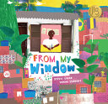

From My Window

2018 by Otávio Júnior and Vanina Starkoff

Setting: Favelas of Rio de Janeiro
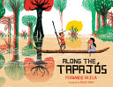

Along the Tapajós

2019 by Daniel Hahn and Fernando Vilela

Setting: Small Community along the Tapajós River
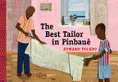

The Best Tailor in Pinbauê

2017 by Eymard Toledo

Setting: Town of Pinbauê - imaginary town in the State of Minas Gerais

* As the author states in the postscript, Pinbauê is a fictional village. However, a Google search for images can help children visualize the setting.
- Small Brazil villages
- Small river towns Brazil
- Minas Gerais
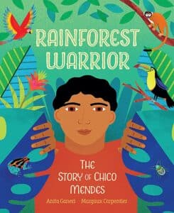
Rainforest Warrior
2023 by Anita Ganeri and Margaux Carpentier
Setting: Amazon Rainforest, Biography of Chico Mendes (union leader and environmentalist)

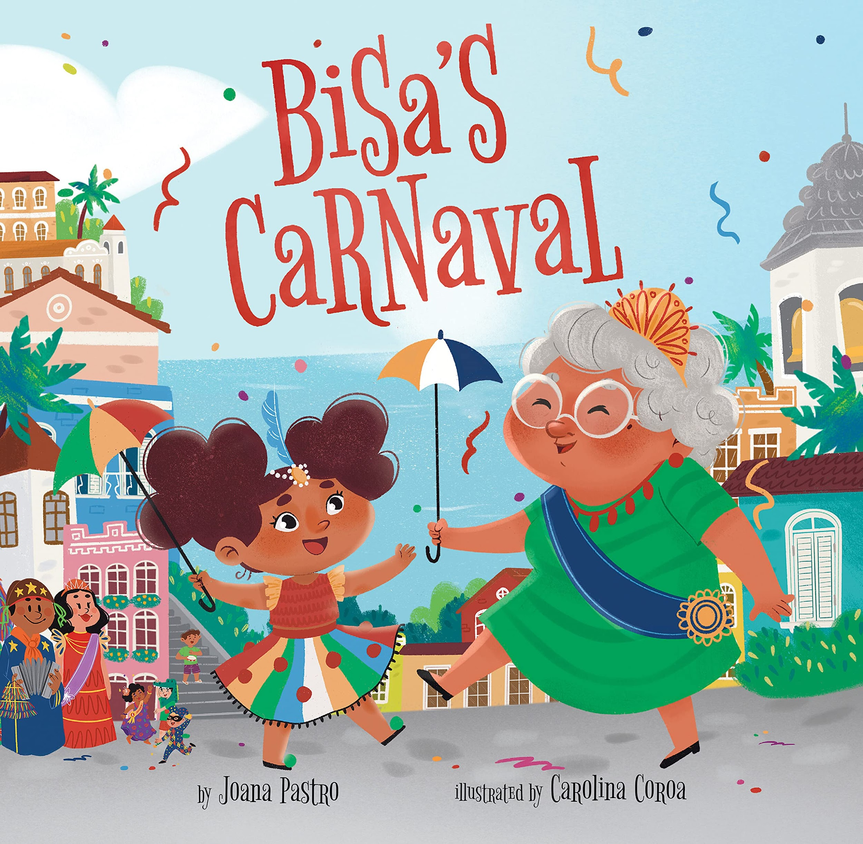

Bisa’s Carnaval

2021 by Joana Pastro and Carolina Coroa (Illustrator)
Setting: Not Clear, Brazil
* I would engage students in a discussion about the size and diversity in Brazil using the internet to research. We could look into how Carnaval is celebrated similarly or differently across Brazil and Latin America.
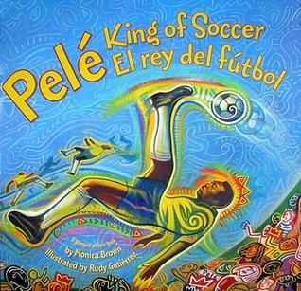
Pelé, King of Soccer/Pelé, El rey del Fútbol
2017 by Monica Brown and Rudy Gutierrez (Illustrator)
Setting: (he grew up in the) Sao Paulo region of Brazil
2. What was your process for literature selection?
When choosing books for this project, I asked myself:
- Is this book written by someone from Brazil? OR Is the author qualified to share this story?
- Is the book using a deficit perspective?
- How is the author portraying the characters? Are common/harmful stereotypes featured?
- Is it based in the past or present?
- Does the book make broad generalizations about a culture or cultures? Is the setting specific or ambiguous?
- Are authentic words from the culture present?
- Do the books balance each other out? Am I presenting too many stories about one topic?
3. Where and how did you learn about this literature (browsing, internet search, award lists, in-person recommendation, etc.)
I learned about these books through recommendations, searching at the MSU library, the Diverse Book Finder website, YouTube read-alouds, University library websites, and blogs with caution.
4. Did you consult some of the resources identified in the library visit and the Zoom meetings?
YES, I used the Diverse Book Finder website and the MSU library.
Lesson
1. What do you want students to learn? (goals)
Brazil is a diverse nation and cannot be represented by a single book, website, or person. Students will also learn more about the diverse settings in Brazil including large cities like Rio de Janeiro and the lush climate of the Amazon. Students will also look into the ways that our globe is impacted by climate change.
Possible Social Studies Standards:
6 – G1.2.3 Use, interpret, and create maps and graphs representing population characteristics, natural features, and land use of the region under study.
6 – G2.2.1 Describe the human characteristics of the region under study, including languages, religions, economic system, governmental system, cultural traditions.
6 – G4.1.3 Describe cultures of the region being studied, including the major languages and religions.
6 – G5.1.2 Explain how different technologies can have positive and negative impacts on the environment.
Michigan K-12 Standards for Social Studies
2. Why does this lesson matter from the perspective of global understanding and engagement? (rationale)
This lesson matters within this global perspective because it addresses issues of misrepresentation and generalization about Brazil. It also is important because it pushes students to think about how our climate is impacted globally by our actions and ways that we can work to help our planet prosper.
3. What will you do? (the actual lesson). Please explain the lesson in detail. Feel free to use whatever format you usually use to create a lesson plan. (You may wish to include artifacts.). You should include theme/topic, global perspective, unit/lesson background, activities/instructional approaches and so on.
My lesson is outlined below in green.
4. How will you know if students learned what you intended? (assessment)
Assessment: Portfolio of their work from this lesson and reflection paper.
Lesson Plan
Day 1: Building Background - Overview of Brazil
Students will do research and create posters (online or using pen and paper) to display important information about Brazil. The purpose of these posters would be to give someone who knows nothing about Brazil a short introduction to the vast country. I will encourage students to showcase the many different landscapes across the huge country. Students are also welcome to include information about any of the following topics (and more):
- Quick Facts: population, area, climate, products, and currency
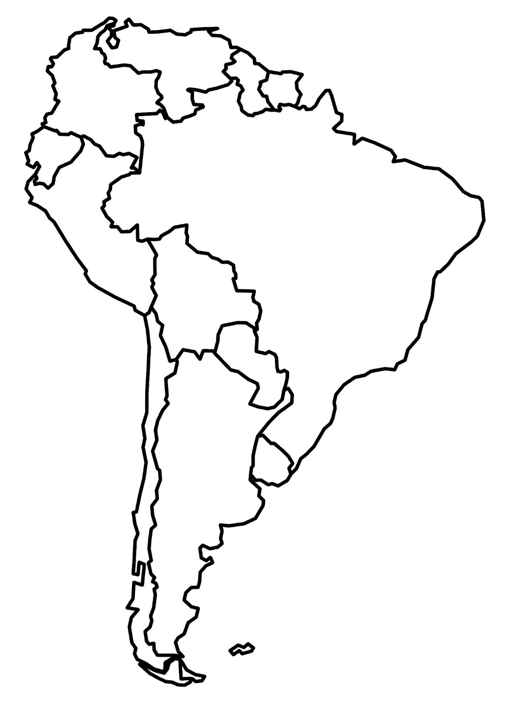
- Flag and its Symbolism
- Common Languages Spoken
- Common Food
- Traditional Clothing
- Popular Sports
- Native Animals
- Important People
- Brazil - Globe Trottin' Kids

I will also introduce this blank map that we will each be working with for the next 5 days to label different regions of Brazil as we read the stories together.
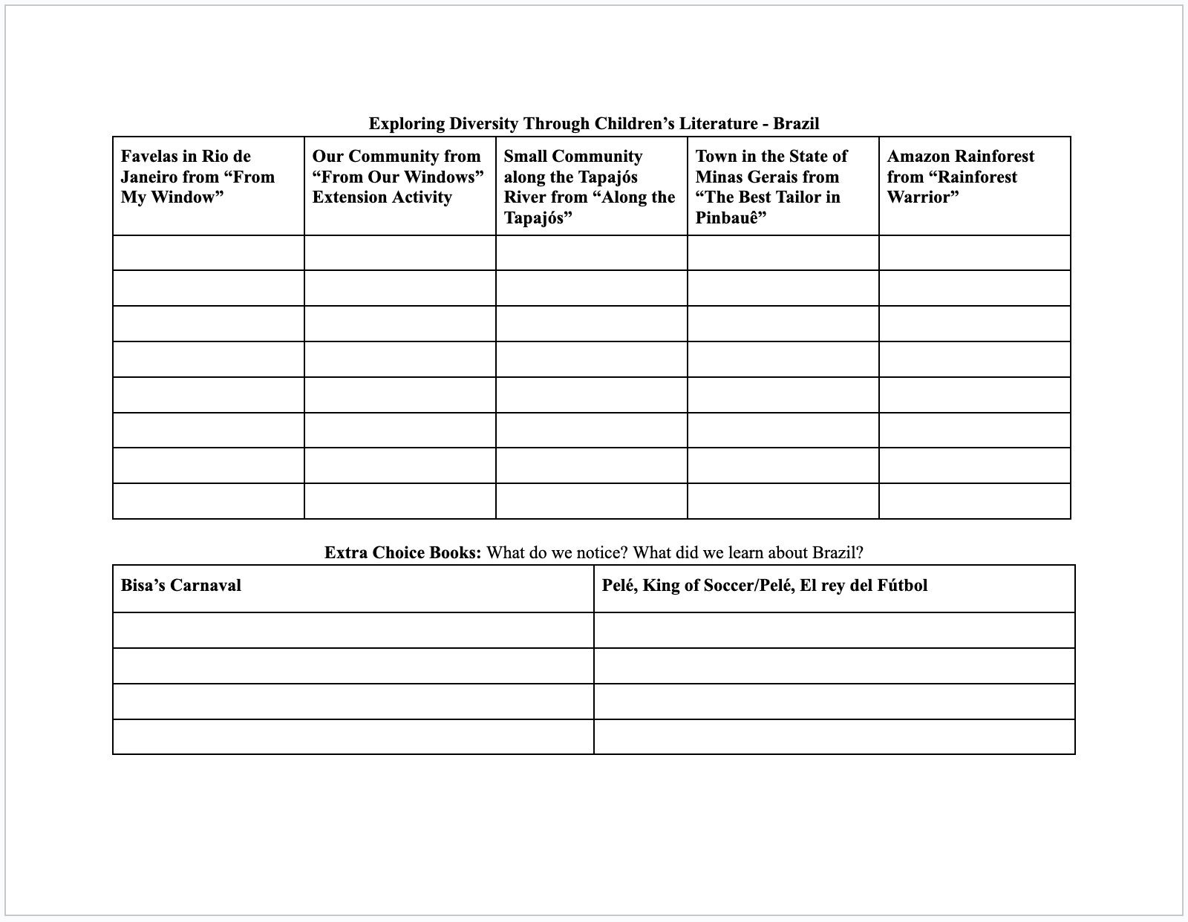
In addition, I will introduce this class T-Chart that we will collectively use to take notes on the different stories we read and how the settings compare to each other.

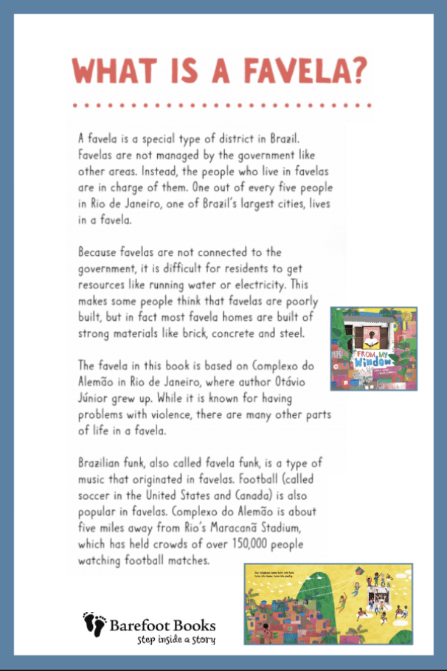
Day 2: Favelas in Rio de Janeiro
Introduce favelas using this resource: From My Window: A Celebration of Community - Globe Trottin' Kids. We will also add the city of Rio de Janeiro to our map of Brazil using Google.
Interactive read-aloud of “From My Window” by Otávio Júnior and Vanina Starkoff, which takes place in the favelas of Rio de Janeiro.
Activity: Students will create drawings and write descriptions of what they see from their own windows. Some prompts to inspire students include but are not limited to:
“What do you see?”
“What is the mood?” “How does it make you feel”
“Are there any characters?”
“What sensory details do you notice?” “Are there any small details?”
“Has the view from your window ever changed?” “How?”
“What else is out there that maybe you cannot see?”
Students should be prepared to share whatever they have completed in a gallery walk around the class.
Discuss some similarities and differences from what the narrator described (and illustrator drew) from the students’ own images and words. Add these to the class T-Chart.
Day 3: Life Along the Tapajós River
Introduce the Tapajós River and its significance in Brazil. Also, discuss Indigenous peoples in the region. Students will browse these sites: Rainforest Tribes Facts – People in the Amazon Rainforest and The Tapajos River to gain more background information about this region and the significance of the water here.
- We will also add the Tapajos River to our map of Brazil.
Interactive read-aloud of “Along the Tapajós” by Daniel Hahn and Fernando Vilela, which is set in a small community along the Tapajós River.
Discuss the differences and similarities between life in the favelas of Rio de Janeiro and life in a small river community. Add these ideas to a class T-Chart.
Activity: Students will be divided into small groups to research one aspect of the Tapajós River. Topics included:
- Biodiversity of plant and animal species
- Indigenous communities and their relationship with the river
- Environmental threats and conservation efforts
- Economic activities such as fishing and tourism
- Geological features and the river's role in the Amazon Basin
In their groups, students will present their findings to the class. Students will be encouraged to use multiple sources and to include visual aids such as posters or slideshows.
Day 4: Exploring the Imaginary Town of Pinbauê
* This resource gave me a lot of ideas for this portion of my lesson: The Best Tailor in Pinbauê - CLAS Book Box K-12 Guide 4: Portuguese and Brazil in PictureBooks
Introduce the fictional town of Pinbauê, located in the State of Minas Gerais:
- It will be crucial that students know that Pinbauê is a fictional town, but that it is inspired by real towns in the State of Minas Gerais.
- To introduce this, we will all do some quick google searches about the State of Minas Gerais and add this region to our map of Brazil.
Interactive read-aloud of “The Best Tailor in Pinbauê” by Eymard Toledo, which is set in the imaginary town of Pinbauê.
Discuss the following questions during/after the book:
- How do you think the villagers felt about all the gray smoke and dust from the factory?
- How has the factory changed Pinbauê? Name some of the good things that come from having the factory in the community. Name some of the negative things that night come from having the factory in the community. Think about the air and the river. Compare the pictures of the river at the beginning and later when the factory is built.
- How do the new colorful clothes make the people in Pinbauê feel?
- When the factory decides to replace the uniforms instead of repairing them, what happens to all the old uniforms?
- What are the benefits of reusing or repurposing old material and clothes instead of simply replacing them with brand new?
Encourage students to compare and contrast the imaginary town of Pinbauê with the favelas and small river communities explored in the previous books. Add these ideas to a class T-Chart.
Activity: Normally we draw with crayons and markers or paint, but what if we could “draw” with shapes and patterns like the illustrator Eymard Toledo did. Students will repurpose old scraps of fabric with different patterns and colors, use scissors to cut small shapes, and assemble them with glue onto a piece of paper to create a scene like the ones we looked at in this book. Students may use other materials to add details to the drawing.
After students complete their images, they will write a brief description of what their collage depicts and why they chose the colors and patterns that they did.
The class will participate in a gallery walk to see all of the different collages along with their descriptions.
Day 5: Environmental Conservation in the Amazon Rainforest
Introduce the Amazon Rainforest and its importance as a global ecosystem using a website such as The Amazon Rainforest.
- We will also add an outline of the Amazon Rainforest to our map of Brazil.
Interactive read-aloud of “Rainforest Warrior” by Anita Ganeri and Margaux Carpentier, a biography of Chico Mendes.
Discuss the following questions during/after the book:
- What kind of person was Chico Mendes? What did he care about?
- How did he help protect the rainforest?
- What did you learn from reading about Chico Mendes? Why is it important to protect the rainforest/the environment?
Students will compare and contrast the scenes in “Rainforest Warrior” with the imaginary town of Pinbauê, the favelas, and the small river communities near the Tapajos that we explored in the previous books. Add these ideas to a class T-Chart.
Activity: Small groups of students will research and present what they found out about current environmental issues in the Amazon Rainforest and ways to support conservation efforts. Students will create a poster to display and present their findings. Each small group will give very informal presentations that will last 1 to 3 minutes.
Additional Class Discussion/Research Questions: What are some environmental problems in our own community? How can we help take care of the environment, like Chico Mendes did? Can you think of ways we can be like Chico Mendes in our own lives, even if we're kids?
Day 6: Choice Book Exploration
Option 1:

Bisa’s Carnaval

2021 by Joana Pastro and Carolina Coroa (Illustrator)
Option 2:
Pelé, King of Soccer/Pelé, el Rey Del Fútbol
2017 by Monica Brown and Rudy Gutierrez (Illustrator)
Pele, King of Soccer/Pele, El Rey del Futbol by Monica Brown - CLAS K-12 Book Box 2: Black/Afro-Latinx identity - Research Guides at Ohio State University
Students will discuss the book they chose and what they learned from it in their small groups. Then, they will start brainstorming for their reflection paper. Students will also have time to finish anything they have not completed for their portfolios.
Day 6: Culmination Activity/Assessment: Portfolio and Reflection Paper
The portfolios will consist of:
- Introduction to Brazil posters
- Labeled map of Brazil
- Individual “From My Window” drawings
- Tapajós River research/group work
- Recycled material collage and description
- Amazon Rainforest research/group work
Reflection Paper: Answer each question with at least four sentences.
- In what ways do you see similarities and differences between your own life and the varied lifestyles of the diverse people in Brazil that you've learned about? What aspects can you personally relate to?
- How did map making help you understand the geography and diverse regions of Brazil? Did you find it challenging or enjoyable to create your own maps?
- Is environmental conservation important in Brazil? Why or why not? What environmental issues did you learn about, and why are they significant?
- How do you think the knowledge and traditions passed down through generations within indigenous communities in Brazil contribute to protecting the environment?
- Consider your own role in environmental conservation. What actions can individuals take to support conservation efforts, both in Brazil and globally? What environmental issues do you see in your own community? What actions can you take to combat these?
- What did you learn from “Bisa’s Carnaval” or “Pelé, King of Soccer/Pelé, el Rey Del Fútbol?” What did this book teach you about Brazil? Do you think this book portrays any stereotypes or generalizations about the people of Brazil?
- Reflect on any personal insights or changes in perspective you've gained from studying these topics. How do you plan to apply what you've learned in your own life or future endeavors?
Enactment
How did the lesson go? - Not Applicable
1. When did you teach the lesson? - Not Applicable
2. What did you do? (sometimes what is done is different from the plan) - Not Applicable
3. How did students respond? (you may wish to include artifacts) - Not Applicable
Reflection
Reflection (Self-evaluation)
1. What were you pleased with? (strategies that worked well)
I did not get the chance to implement this lesson, but having students do some background research on the region or culture before introducing the literature can be helpful to build context and further challenge stereotypes. For example, using websites such as Brazil - Students | Britannica Kids | Homework Help, Brazil Country Profile - National Geographic Kids, 10 amazing Amazon facts! | National Geographic Kids, Top 10 Facts about Brazil - Fun Kids - the UK's children's radio station, Rainforest Tribes Facts – People in the Amazon Rainforest, Brazil - Globe Trottin' Kids, or The Tapajos River all give insight into the country and its diverse landscapes and people.
2. Are there things you learned for next time? (strategies that worked less well)
From this process, I learned about the importance of picking an array of books. I thought about condensing my lesson by reducing the number of books that I would use, but I thought that this could raise concerns about stereotyping. I thought about the danger of a single story and decided I wanted to include stories featuring the vast lifestyles.
3. Were there any surprises? (positive or negative)
While locating books I was surprised how few books there seemed to be about specific places in Brazil. Brazil is a huge country, so I expected there to be more diverse lives pictured in the children’s literature, but most of the stories were either about the Amazon Rainforest, folktales, or described a family’s vacation to Brazil. Finding books took more work than I had anticipated at first.
4. What recommendations do you have for other teachers when using these books?
If other teachers were using these books I would recommend using at least 2-3 of them together. I think that if this lesson included only one of any of these books it could lead to large generalizations that could misrepresent the diverse country that is Brazil.
5. What did this experience teach you about global children’s literature and including global children’s literature in your curriculum?
This experience expanded on my knowledge of the importance of global literature. This process showed me how I have to put in effort to make sure my future classroom library is representative of the world, not just the students in my classroom. I also have learned more about the importance of truly vetting everything that I will be making available to my students as well as teaching them how to critically analyze texts.
6. Question: Because I do not have a lot of experience with time management in a real classroom, I am wondering if I am being too ambitious with how much I think we could accomplish within a given time frame.
- Do you think all of my lesson outlines would be doable within a 45 minute-1 hour long time period each day?
References
List all references or resources you used.
Diverse Book Finder: Brazil
Picture Books about Brazil (Cultural Learning for Homeschoolers)
CLAS Book Box K-12 Guide 4: Portuguese and Brazil in PictureBooks - Research Guides at Ohio State University
From My Window: A Celebration of Community - Globe Trottin' Kids
Pele, King of Soccer/Pele, El Rey del Futbol by Monica Brown - CLAS K-12 Book Box 2: Black/Afro-Latinx identity - Research Guides at Ohio State University

