**G. W. Bird Family Foundation for Environmentally-Sound Agriculture**

**Environmentally-Sound Agriculture Day**

**November 21, 2024 (Thursday)**

11:30-1:00 *Environmentally-Sound Rice Production Symposium*

Shekhar Bhadsavle, Saguna Rural Foundation (India) and Karim Maredia, Michigan State University

Room 303-305, International Ctr,

4:00-5:00 Keynote Address

*Strengthening Resiliency of Agriculture and Food Systems in Michigan: Challenges and Opportunities*

Dr. George A. Smith, Director, AgBioResearch, MSU

Room 122B, Wells Hall, MSU

6:00-8:30 Scholarship and Hero Awards Banquet (by invitation)

Reception (6:00-6:30 p.m.)

Dinner (6:30-7:30 p.m.)

Environmentally-Sound Agriculture Scholarship and Hero Award Ceremony (7:30-8:30 p.m.)

8:30-9:00 Post-program coffee and

informal individual/group discussion.

University Club of MSU

3435 Forest Road, Lansing, Michigan

**George A. Smith**

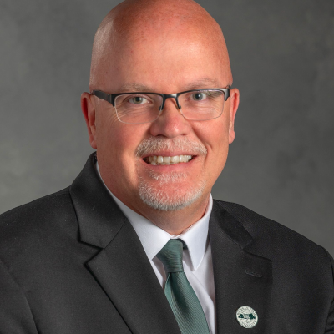

As Director of AgBioResearch, Dr. Smith is responsible for administrative oversight for the organization. AgBioResearch’s university-wide mission is to conduct research related to Michigan’s highly diverse food systems and natural resources. AgBioResearcch directly supports about 300 scientists from seven MSU colleges and 15 outlying research and Extension centers. Director Smith obtained his B.S. degree in animal science from the University of Idaho, and the M.S. and Ph.D. degrees in animal science and reproductive physiology from the University of Missouri-Columbia. He joined the MSU faculty in 1997. His research focused on dairy cattle reproduction. In 2020, Dr. Smith transitioned to full-time research administration responsibilities. In August of this year, he exhibited his evolving national leadership in a presentation in to U.S. agricultural journalists at their annual Ag Media Summit in Kansas City, Missouri, and more recently wrote on the significance of Michigan’s water resources to agriculture and the general public.