2024 Global Children’s Literature Teacher Fellowship Program Lesson Plan Template
Context
Lesson Title:
What was the context for your lesson?
1. Your grade level 2-5th Grade
2. The subject area(s) for which you created the lesson- English language Arts
3. The make-up of your class (rural, urban, etc.; diverse, homogenous, etc.) and how that helped you think about your lesson- I service students with Individualized Education Plans (IEPs). This means all of my students have a disability that impacts their school day. I work in a suburban school district in a building with school-of-choice students. Our school is incredibly diverse because of our proximity to Michigan State University. We have students from countries all over the world. In my classroom, I have one student born in another country, but the remaining are first--, second-, or third-generation immigrants.
4. Your own identities and how they play into your lesson (here, you might think of how your identities and experiences might affect what and how you plan to teach this lesson).
I am a white cis-gendered woman who comes from parents who both have college degrees and grandparents who ¾ had/have a college degree. Because of this information, I must rely on others and their perspectives.
Process:
How did you select the literature for your lesson? When selecting literature, I chose something I felt would speak to my students. I wanted to pick something that spoke to them as learners with disabilities. This was a challenge, but I found a few options.
1. What literature will you use?
I chose a Sky Blue Bench by Bahram Rahman.
2. What was your process for literature selection?
I searched for my world region (Asia) through the diverse book finder. I then used the content search for disabilities to find texts about students with disabilities. The literature I chose is not just about students with disabilities but also reflects their experiences and challenges, making it more relatable and engaging for them.
3. Where and how did you learn about this literature (browsing, internet search, award lists, in-person recommendation, etc.)
I used the Diverse Book Finder.
4. Did you consult some resources identified in the library visit and the Zoom meetings?
I used the Diverse Book Finder, which I learned about through the library visit.
Lesson
1. What do you want students to learn? (goals) I want my students to learn that there are students all over the world like them. They already look different from the world and their Peers. I think they likely don’t realize that there are kids like them all over. I want them to make a text-to-self connection and write a short paragraph on that topic.
2. Why does this lesson matter from the perspective of global understanding and engagement? (rationale) This lesson holds significant importance in fostering international understanding and engagement because it can broaden students' perspectives beyond their immediate surroundings. Students are prompted to recognize the universality of human experiences across the globe by facilitating connections with peers from diverse backgrounds who share similar struggles. Such interactions cultivate empathy and compassion and instill a sense of interconnectedness among young learners. In a world increasingly interconnected through technology and globalization, nurturing a global mindset from an early age is essential in preparing students to navigate and contribute positively to our increasingly diverse and interconnected world. Therefore, this lesson is a powerful tool for promoting cultural awareness, empathy, and a deeper appreciation for global diversity, ultimately shaping students into informed and empathetic global citizens.

3. What will you do? (the actual lesson). Please explain the lesson in detail. Feel free to use whatever format you usually use to create a lesson plan. (You may wish to include artifacts.). You should include the theme/topic, global perspective, unit/lesson background, activities/instructional approaches, etc.

Activities:
(Google Sides)
Objective:
- Students will be able to craft a three-sentence paragraph recalling a personal experience of overcoming a challenge.
Assessment:
- Students will be assessed based on their ability to effectively articulate a personal experience of overcoming a challenge in a three-sentence paragraph.
Key Points:
- Understanding the elements of a personal narrative
- Reflection on personal challenges and victories
- Practicing concise and coherent writing skills
- Utilizing a 5-finger retell technique to summarize a story
- Making connections between personal experiences and storytelling
Opening:
- Make predictions about the book based on the cover art
- Review a world map and locate Afghanistan and its location compared to our current location

Introduction to New Material:
- View pictures of the characters and provide a brief description of the characters
Read the story
Guided Practice:
- Complete a five-finger retelling of the story as a whole group.
Independent Work:
- The students complete a brainstorming word cloud about a time they had to overcome something in their lifetime.
- Then, students transfer information from their brainstorming into a short three-sentence paragraph about something they had to overcome.
Closing:
- For the closing activity, have students pair up and share their three-sentence paragraphs with a partner.
- Ask a few volunteers to share their paragraphs with the class, highlighting the uniqueness of each personal story.
Standards Addressed:
- Common Core Standard: CCSS.ELA-LITERACY.W.3.3 - Write narratives to develop real or imagined experiences or events using effective techniques, descriptive details, and clear event sequences.
4. How will you know if students learned what you intended? (assessment)
- Students will complete a 3 paragraph assignment in a time that has to overcome something.
Enactment
- How did the lesson go?
  - The lesson went extremely well. I was surprised with how engaged the students were with the content!
- When did you teach the lesson?
  - I taught the lesson the week of 4/1 during a 50-minute writing block.
- What did you do? (sometimes what is done is different from the plan)
  - I needed to split up the lesson across two days. The plan was to try and teach it one day, but due to time constraints and our pleasant conversations, we ran out of time on day one, so I extended the context.
3. How did students respond? (you may wish to include artifacts)
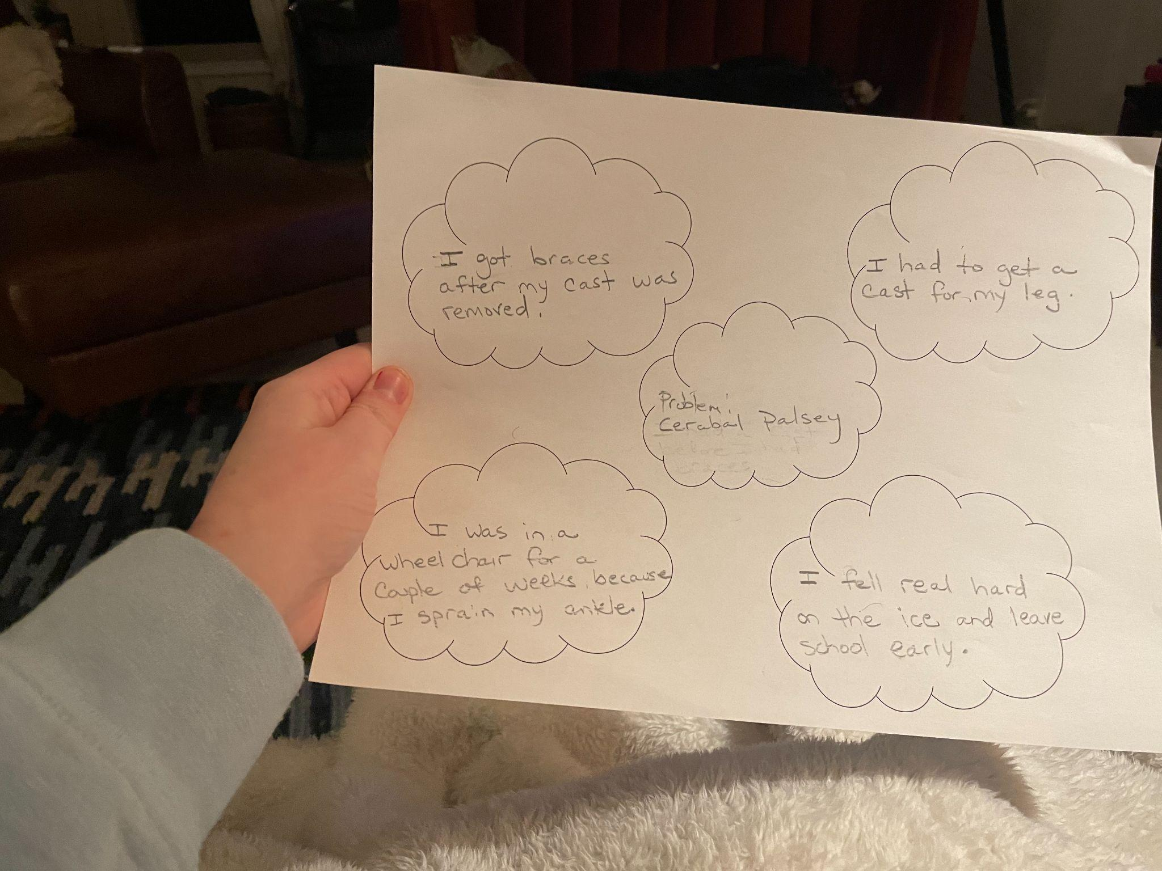
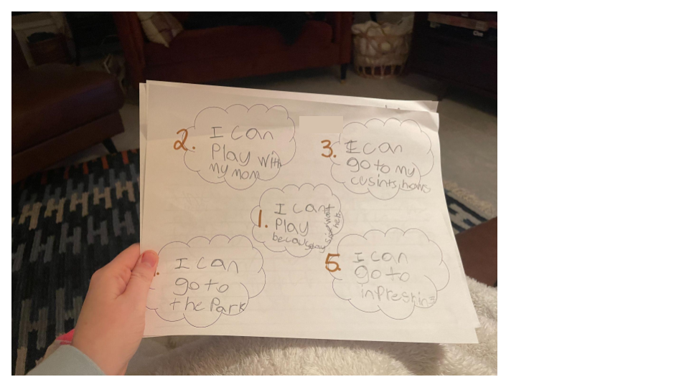
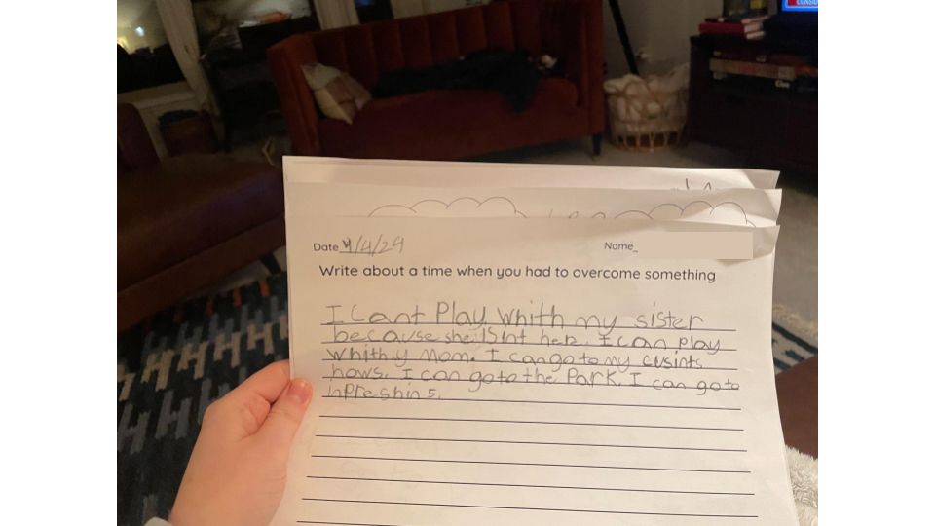
My students were so excited and loved the story. It inspired me to incorporate more texts.
Reflection
Reflection (Self-evaluation)
1. What were you pleased with? (strategies that worked well)
Students were incredibly engaged with the story! The beautiful illustrations and excellent story context helped students engage.
2. Are there things you learned for next time? (strategies that worked less well)
Next time, I plan on the lesson being more of a week-long lesson. I would have loved to have time for the writing process.
3. Were there any surprises? (positive or negative)
I was pretty surprised with how engaged students were with the process. They had some fantastic questions about why the girl was wearing a hijab, why boys don’t wear a hijab, why she may have lost her leg, and why she needed to go to school.
4. What are your recommendations for other teachers when using this book?
I recommend digging into the story and giving yourself ample time to complete the lesson. I would love to incorporate an art lesson or project into this story.
5. What did this experience teach you about including global children’s literature in your curriculum?
I learned about the danger of a single story and how that impacts all learners. I also learned that there is a lack of books from diverse authors.
References
List all references or resources you used.
Middle East Book Award
Pajama Press
Peggy Collins
Awards

