2024 Global Children’s Literature Teacher Fellowship Program Lesson Plan Template
Context
Lesson Title:
What was the context for your lesson?
1. Your grade level: K - 4
2. The subject area(s) for which you created the lesson: Small Group Reading
3. The makeup of your class (rural, urban etc.; diverse, homogenous, etc.) and how that helped you think about your lesson:
Demographics: Burton 48509
Group 1: girls-5 boys- 3
Caucasian- 3, African American- 4, Biracial 1
Group 2: girls-3 boys- 4
Caucasian- 6, African American- 1
4. Your own identities and how they play into your lesson (here, you might think of how your identities and experiences might affect what and how you plan to teach this lesson):
I was born in Des Moines Iowa. My father was a well educated caucasian English man, my mother a first generation American born to 2 Maltiza citizens who both came to America as young children. In Iowa my mother was seen as “the token black” teacher, as she had black hair and was definitely the darkest person around. I grew up around and in mostly caucasian areas when I was young. I remember my parents being friends with a wonderful African American couple when I was young. We moved to Flint Twp., Michigan when I was in fourth grade and continued attending a small Christian school. In 6th grade my parents had a very ugly divorce which continued on for 7 years. Honestly as I grew and began to date only African American men. Subconsciously I believe the way my father treated my mother in the end of their marriage and through the divorce I was not going to allow the same thing to happen to me. I also saw the benefits of both races and was hopeful as a young adult my children could have the best of both worlds. Sadly realizing especially after the 2016 election how divided and still racist a lot of the world is. I currently teach in a very previously separated area that is non-transient and several generations have attended our district.

Process
How did you select the literature for your lesson?
1. What literature will you use?
Your Name Is a Song by Jamilah Thompkins-Bigelow

2. What was your process for literature selection?
- I looked through several of the lists that were given to us on our library visit and I tried to focus on award winning literature.
- I also did many searches of my own and started noticing book titles that showed up often and on many lists.
- I narrowed my search down a bit once I started thinking about what I wanted to focus my lesson on. Here, I feel I must explain, I say narrowed, but what I mean by narrowed is looking for specific topics and titles. I am using many books for my series of lessons, but they are specific to my lesson and intentionally chosen.
3. Where and how did you learn about this literature (browsing, internet search, award lists, in-person recommendation, etc.)
- During our class sessions
- Asking an author and friend for suggestions
- The library visit and website
- Online searches of my own
4. Did you consult some of the resources identified in the library visit and the Zoom meetings?
Yes
1. What do you want students to learn? (goals)
I would like this lesson to lead to the learning of a wide range of positive student outcomes, including the meaning and possibly the origin of their name, empathy, cultural awareness, identity development, and promotion of diversity and inclusion.
2. Why does this lesson matter from the perspective of global understanding and engagement? (rationale)
I would like to help students learn the value of words. Learn what their own name means as well as others, and learn to appreciate and respect everyone.
3. What will you do? (the actual lesson). Please explain the lesson in detail. Feel free to use whatever format you usually use to create a lesson plan. (You may wish to include artifacts.). You should include theme/topic, global perspective, unit/lesson background, activities/instructional approaches and so on.

Monday:
- Discussion questions before Reading
  - What do you think the story will be about?
  - Look at the front cover, what predictions can you make about the story?
  - Do you like your name? Why or why not?
  - Why are names important?
- Listen to the story
  - https://youtu.be/ZmXqJGherE8
- Questions for during or after Reading
  - Who are the characters in the story?
  - What is the setting of the story?
  - What happened in the story?
  - What was the problem in the story?
  - What was the solution?
  - Has someone said your name incorrectly?
  - How did it make your feel?
  - Why is it so important to say everyone’s name the right way?
  - What would you do if someone said your name incorrectly?
  - Do you have a special nickname?
  - What does Kora-Jalimuso mean when she says her name gets stuck in her teacher’s mouth?
  - Why didn’t Kora-Jalimuso want to go back to school?
  - What does she say she has to teach?
  - How did the teacher react to her singing the names? The kids?
- Send Tell Us Homework home
  - Tell Us

Tuesday:
- Learn about the Author
- https://jamilahthewriter.com/
- Introduce students to the map of Africa :
  - https://www.africaguide.com/afmap.htm
  - Discuss maps and initial things we know or think we know.
- Learn more about her ethnic group:
  - https://www.yaden-africa.com/the-culture/african-tribes/mandinka

Wednesday:
- Listen to the story
  - https://youtu.be/ZmXqJGherE8
- Letters in Name
  - Letters
  - Graph

Thursday:
- Go over Homework:
  - Tell Us

- Make Name Poems:
  - Write your name in BOLD letters across the top.
    - Name Poem
    - Find positive adjectives that correspond with each letter of thor name.
Friday:
- Read the story
  - 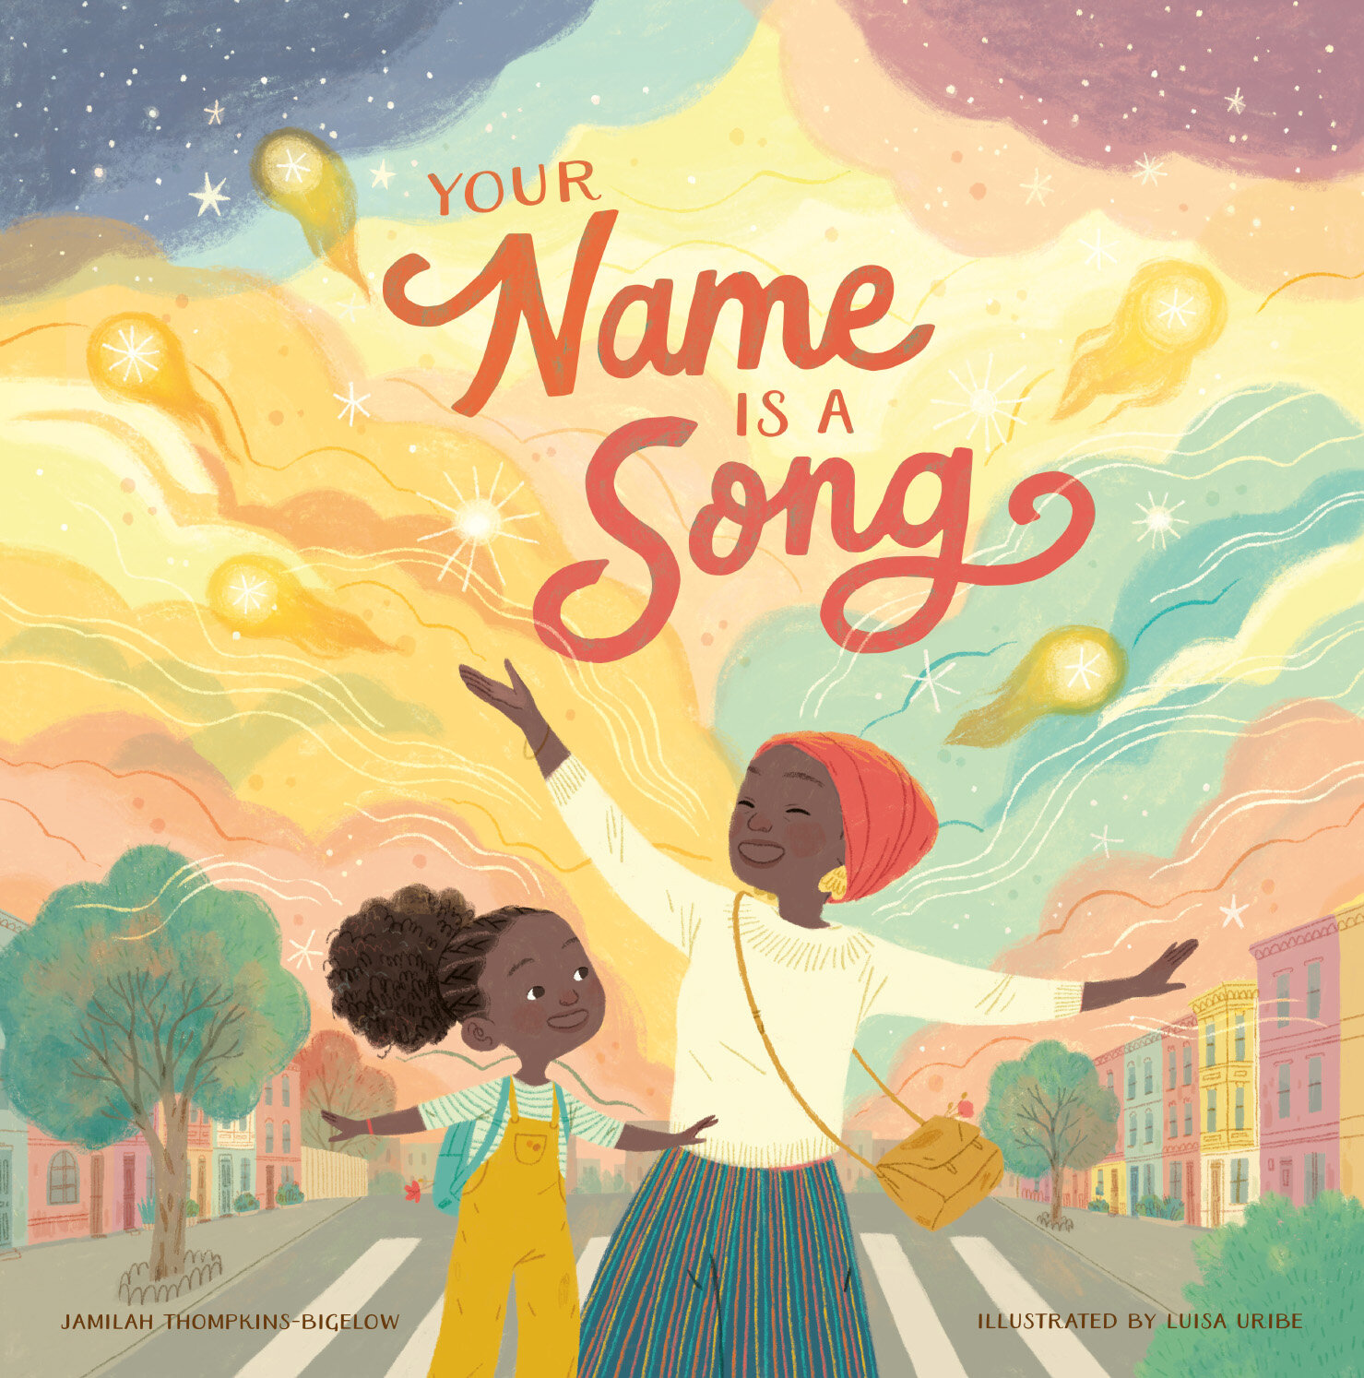
  - I used to Think now
  - Story Map

4. How will you know if students learned what you intended? (assessment)

- I used to Think now
- Story Map

Enactment
How did the lesson go?
1. When did you teach the lesson? April 1-4, 2024
2. What did you do?
I followed the lesson plan
3. How did students respond?
Students really enjoyed the lessons and activities. They were active learners and engaged. They were considerate of others and enjoyed learning about their names and others.
Reflection
Reflection (Self-evaluation)
1. What were you pleased with? (strategies that worked well)
I was pleased with the engagement and interest level of the students. They seemed to really be interested in learning about Latin America. They also appeared to enjoy the activities I provided for them. I was so thrilled with the observations and connections they were able to make throughout the lesson
2. Are there things you learned for next time? (strategies that worked less well)
I would rethink the I used to Think activity. I would still use it, however, I believe I would like to make it easier for younger kids to use, maybe draw pictures.
3. Were there any surprises? (positive or negative)
I was surprised that many of my students had no idea what their name meant. I also was surprised they did not know who chose their name and why or where their name was chosen.

4. What recommendations do you have for other teachers when using this book
I recommend using the book over several days as I did. Allowing the students time to bring back the information about their name over several days, and sending an email or note directly to parents.

5. What did this experience teach you about global children’s literature and including global children’s literature in your curriculum?
This experience taught me how little students in my area know about themselves and others. Also sadly how much misinformation students have been taught about others.
References
List all references or resources you used.
https://jamilahthewriter.com/about/

Demographics: Burton 48509
https://youtu.be/ZmXqJGherE8

https://www.africaguide.com/afmap.htm

https://www.yaden-africa.com/the-culture/african-tribes/mandinka

Picture books used:
Your Name Is a Song
Book by Jamilah Thompkins-Bigelow

